Richard L. Wasson
March 4, 1926 – April 17, 2014

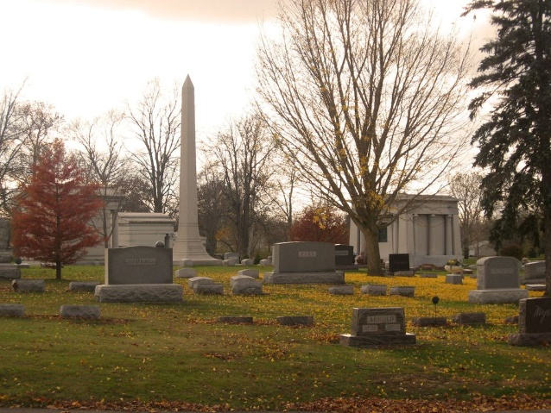
Photo by Tombstoner & Family

Richard L Wasson
in the Indiana, U.S., Death Certificates, 1899-2017
Name Richard L Wasson
Gender Male
Race White
Age 88
Birth Date 4 Mar 1926
Birth Place Bluffton, Indiana
Death Date 17 Apr 2014
Death Place Decatur, Adams, Indiana, USA
Death Registration Date 2014
Father Laverne W Wasson
Mother Vada B Woodward
Informant Adam Miller; attorney; Decatur, Indiana
Burial Elm Grove Cemetery; Bluffton, Indiana
Certificate Number 017696

