Pearl Rose (Warner) Wasson
May 26, 1876 – March 29, 1926

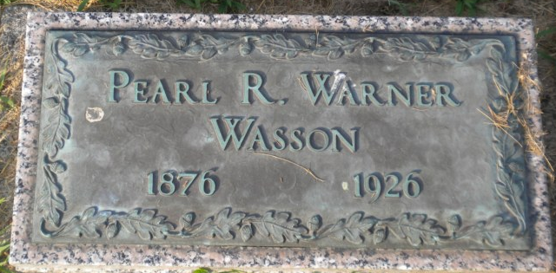
Photo by PLGS

Mrs. William T. Wasson, 50, died of heart disease at 1 o'clock this afternoon at the county hospital here. Her home is at 316 West Washington Street, this city.
Surviving is the husband, four children and the parents, Mr. and Mrs. James Warner of Hartford City.
Funeral services will be held at the First Presbyterian Church here and burial will be at Elm Grove Cemetery.

Muncie Morning Star, Muncie, Indiana
Tuesday, March 30, 1926

**
Indiana, U.S., Death Certificates, 1899-2017
Name Pearl Rose Warner Wasson
[Pearl Rose Warner]
Gender Female
Race White
Marital Status Married
Age 50
Birth Date 26 May 1876
Birth Place Clinton County, Ohio
Death Date 29 Mar 1926
Death Place Bluffton, Wells, Indiana, USA
Death Registration Date 1926-1927
Father James Warner
Mother Etta Thompson
Spouse William T. Wasson
Informant William T. Wasson; Bluffton, Indiana
Burial March 31, 1926; Elm Grove Cemetery

