Paul E. Wasson
December 29, 1908 – August 31, 1973

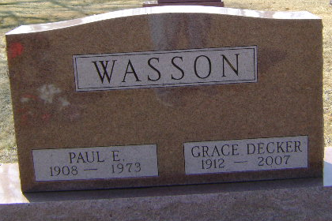
Photo by Bruce Sonner
Mrs. Habegger’s Brother Dies
Paul E. Wasson, 64, of Bluffton, brother of Mrs. Ralph (Mary Margaret) Habegger of Decatur, died at 1:30 p.m. Friday in Wells Community Hospital. Funeral services were held at the Thoma-Rich Funeral Home Sunday. Burial was in the Elm Grove Cemetery. He had been ill four days, having suffered a stroke while at work.
He was employed by the Erie Stone Co. 37 years. Born in Wells County on Dec. 29, 1908, he was a son of Frank and Lola (Wible) Wasson, and was married to Grace Decker on Aug. 11, 1935.
Surviving are the wife; two sons, Ted D. Wasson of Huntington Woods, Mich., and Don E. Wasson of Albuquerque, N.M.; a sister, Mrs. Ralph (Mary Margaret) Habegger of Decatur, and four grandchildren.
Mr. Wasson was a member of the First United Church of Christ.

Decatur Daily Democrat, Adams County, Indiana
Tuesday, September 4, 1973

