Myna R. (Heckley) Wasson
November 30, 1886 – December 9, 1975

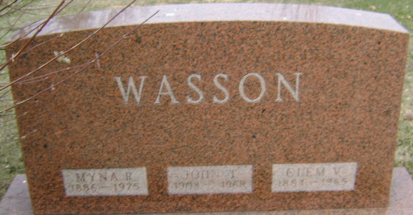
Photo by PLGS

Mrs. Myna Wasson, 89, a native of Wells County and a former resident of Linn Grove, died at 5:30 p.m. Sunday at the Decatur Community Care Center. She had been in failing health for two years.
Mrs. Wasson was a member of the Tocsin United Methodist Church.
She was born in Wells County on Nov. 30, 1886, the daughter of John and Clara Kleinknight-Heckley, and was married to Clem V. Wasson in Wells County on June 28, 1906. He preceded her in death in September of 1965.
Survivors include a son, William Wasson, LaHabra, Calif.; a daughter, Mrs. Hubert (Clara) Wheeler, Linn Grove; two brothers, Harley and Henry Heckley; and one sister, Mrs. George (Martha) Yager, all of Ossian; seven grandchildren and 11 great-grandchildren.
Funeral services will be held at 10 a.m. Wednesday at the Thoma-Rich Funeral Home in Bluffton, where friends may call after 1 p.m. today. Rev. Bruce Kenline will officiate at the services and burial will be in Elm Grove Cemetery.

Decatur Daily Democrat, Adams County, Indiana
Tuesday, December 9, 1975

