Mary Viola “Lola” (Wibel) Wasson
December 4, 1874 – September 30, 1947

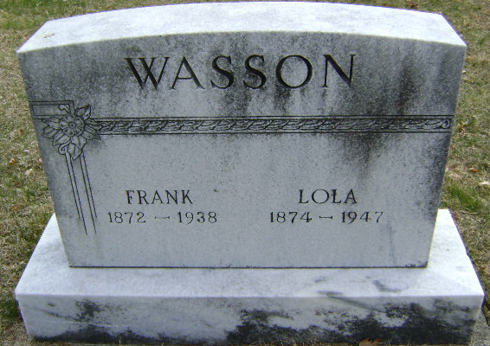
Photo by Bruce Sonner

Mary Diana Wasson
in the Indiana, U.S., Death Certificates, 1899-2017
Name Mary Viola Wasson
[Mary Viola Wibel]
Gender Female
Race White
Marital Status Widowed
Age 72
Birth Date 4 Dec 1874
Birth Place Wells County, Indiana
Death Date 30 Sep 1947
Death Place Bluffton, Wells, Indiana, USA
Death Registration Date 1947
Father John Wibel
Mother Margaret Mills
Spouse Frank Wasson
Informant Mrs. H. F. Fry; Fort Wayne, Indiana
Burial October 2, 1947; Elm Grove Cemetery; Bluffton, Indiana

