Mary Frances (Arnold) Wasson
February 27, 1892 – September 20, 1979

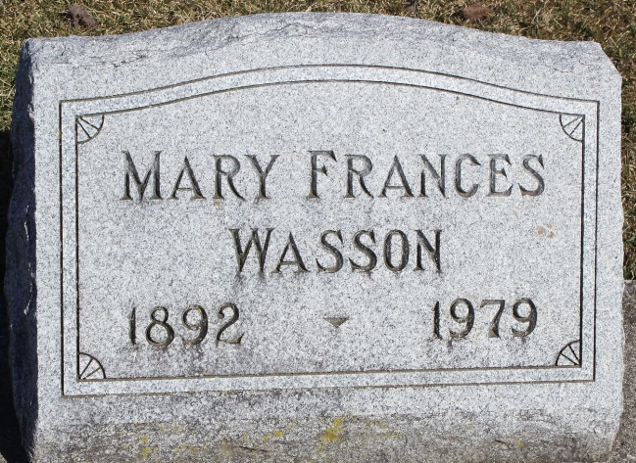
Photo by Tombstoner & Family

Mary Frances Wasson
in the Indiana, U.S., Death Certificates, 1899-2017
Name Mary Frances Wasson
[Mary Frances Arnold]
Gender Female
Race White
Marital Status Widowed
Age 87
Birth Date 27 Feb 1892
Birth Place Ohio
Death Date 20 Sep 1979
Death Place Franklin, Johnson, Indiana, USA
Death Registration Date 1979
Father Lewis C Arnold
Mother Fannie Ann Thomas
Informant Frances Jones; Whiteland, Indiana
Burial September 24, 1979; Elm Grove Cemetery; Bluffton, Indiana

