Lantz L. Wasson
March 2, 1892 – June 23, 1950

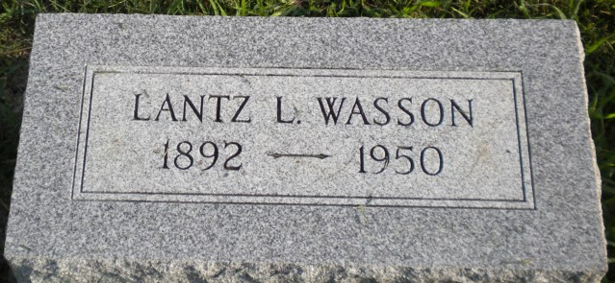
Photo by PLGS

Lantz L Wasson
in the Indiana, U.S., Death Certificates, 1899-2017
Name Lantz L Wasson
Gender Male
Race White
Marital Status Married
Age 58
Birth Date 2 Mar 1892
Birth Place Indiana
Death Date 23 Jun 1950
Death Place Bluffton, Wells, Indiana, USA
Death Registration Date 1950
Father William H Wasson
Mother Etta A McAfee
Informant Mrs. Mae Wasson
Burial June 25, 1950; Six Mile Cemetery; Wells County, Indiana (sic)

