LaVerne W. Wasson
August 23, 1898 – December 27, 1969

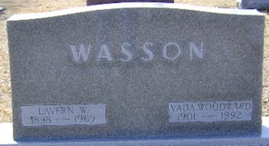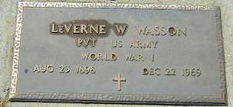
Photo by PLGS

LaVerne W. Wasson, 71, of Fort Wayne died today at Manatee Memorial Hospital at Bradenton, Florida where he had been a patient several weeks. A native of Wells County, he was born August 23, 1898, a son of Frank and Lola Weible Wasson. His marriage to Vada Woodward, who survives, took place November 10, 1920 in Bluffton.
Mr. Wasson retired three years ago as a wholesale buyer for the Food Marketing Company. A veteran of World War I, he was a member of the First United Methodist Church and Bluffton American Legion.
Surviving in addition to the wife are a son, Richard L. of Decatur; a brother, Paul of Bluffton and a sister, Mrs. Ralph (Margaret) Habegger of Decatur.
The Thoma Funeral Home is in charge where services will be held on Saturday. Burial will be in Elm Grove Cemetery.

Bluffton News-Banner, Wells County, Indiana
December 27, 1969

**
U.S., Social Security Death Index, 1935-2014
Name Laverne Wasson
Social Security Number xxx
Birth Date 23 Aug 1898
Issue year Before 1951
Issue State Illinois
Last Residence 46804, Fort Wayne, Allen, Indiana, USA
Death Date Dec 1969

