Juanita Jane (Fruchte) Wasson
August 21, 1927 – November 22, 1992

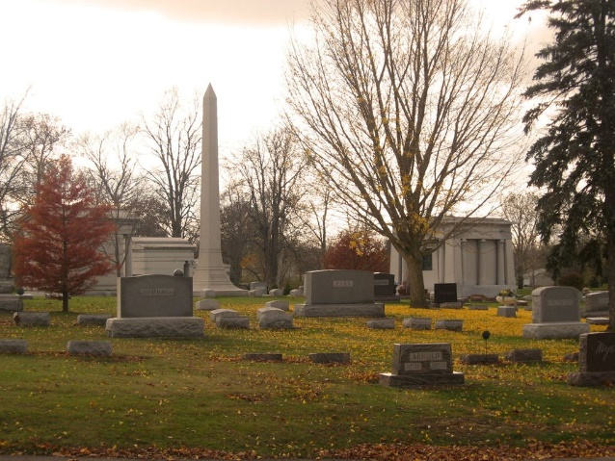
Photo by Tombstoner & Family

Juanita Jane Wasson
in the Indiana, U.S., Death Certificates, 1899-2017
Name Juanita Jane Wasson
[Juanita Jane Fruchte]
Gender Female
Race White
Marital Status Married
Age 65
Birth Date 21 Aug 1927
Birth Place Adams County, Indiana
Death Date 22 Nov 1992
Death Place Decatur, Adams, Indiana, USA
Death Registration Date 1992
Father Albert H Fruchte
Mother Alma A Kruetzman
Spouse Richard L Wasson
Informant Richard L. Wasson; husband; Decatur, Indiana
Burial November 25, 1992; Elm Grove Cemetery; Bluffton, Indiana

