John T. Wasson
February 17, 1908 – December 1, 1968

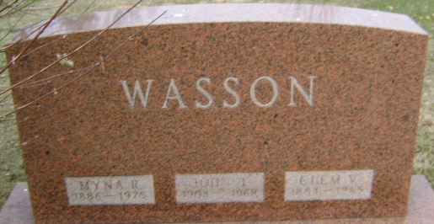
Photo by Bruce Sonner

John Wasson, 60, died at the Cooper Rest Home Sunday. He had been bedfast 18 years and death was due to multiple sclerosis. A son of Clem and Myna Heckley Wasson, he was born February 17, 1908 in Wells County. His marriage was to Belle Hybarger, who survives.
Mr. Wasson had resided in Adams County the last eight years.
Surviving in addition to the wife are the mother, who resides at Linn Grove; a stepdaughter, Mrs. Betty Lou Carey of Paris, Illinois; a sister, Mrs. Clara Wheeler of Linn Grove and a brother, William Wasson of LaHabra, California.
The body was taken to the Thoma Funeral home, burial in Elm Grove Cemetery.

Bluffton News-Banner, Wells County, Indiana
December 1, 1968

**
Indiana, U.S., Death Certificates, 1899-2017

Name John Wasson
Gender Male
Race White
Marital Status Married
Age 60
Birth Date 17 Feb 1908
Birth Place Indiana
Death Date 1 Dec 1968
Death Place Bluffton, Wells, Indiana, USA
Death Registration Date 1968
Father Clem Wasson
Mother Myrna Heckley
Spouse Belle T Hybarger
Informant Mrs. John Wasson; wife; Paris, Illinois
Burial December 4, 1968; Elm Grove Cemetery; Bluffton, Indiana

