John Leo Wasson
August 21, 1893 – July 25, 1981

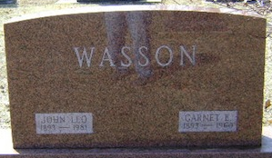
Photo by Bruce Sonner

EX-CRAIGVILLE POSTMASTER, LEO (PETE) WASSON, 87, DIES
A resident of 119 East Townley St. the past 16 years, John Leo (Pete) Wasson, 87, died at 7:20 p.m. Saturday at Wells Community Hospital, where he had been a patient three weeks following surgeries.
Mr. Wasson was postmaster at Craigville for a period of 20 years and served eight years as trustee of Lancaster Twp. A member of the Tocsin United Methodist Church, he also held memberships in the Ossian Masonic Lodge, Fort Wayne Scottish Rite and Bluffton Elks Lodge.
Born Aug. 21, 1893 in Wells County, he was a son of Thomas and Louisa Gephart Wasson. His marriage Nov 1914 (sic) in Wells County was to Garnett Hall, who died Aug. 12, 1960. A second marriage was to Esther Strickler, who died April 1, 1976.
Surviving are two daughters, Mrs. Don (Madge) Hetrick and Mrs. Walter (Myrl) Kipfer, both of Fort Wayne, four grandchildren and one great-grandchild.
Friends will be received from 2 to 5 and 7 to 9 p.m. today at Elzey-Dickey-Haggard Funeral Home in Ossian. Services there at 1:30 p.m. Tuesday will be in charge of Rev. Carl Roark and burial will be in Elm Grove Cemetery.

News Banner, Wells County, Indiana
Monday, July 27, 1981

