James Wasson
April 2, 1841 – March 25, 1918

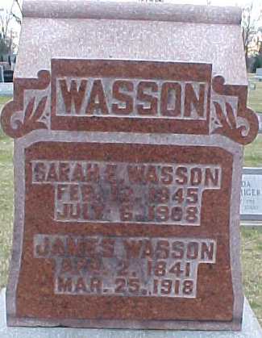
Photo by PLGS

Death near Tocsin

James Wasson, 77, one of the pioneers of Wells County, died at his home near Tocsin Monday morning. A few weeks ago he suffered a fracture of his hip while handling some hay and never recovered from his injury.
Mrs. Wasson died in 1910, but the three children survive. They are Mrs. Maggie Garton, Ray and Irvin Wasson, of Lancaster Township.
The funeral service will be held at 1:30 o’clock Wednesday afternoon at the Tocsin U. B. Church. Burial will be in Elm Grove Cemetery here.
The G. A. R. will assist in the service, Mr. Wasson having been a member of the organization. He was the first man of Company G, of the One Hundred and First Indiana to be wounded in the battle of Chickamauga.

Fort Wayne News and Sentinel, Allen County, Indiana
Tuesday, March 26, 1918
Page 11

