Isabelle Wasson
October 1, 1839 – August 14, 1921

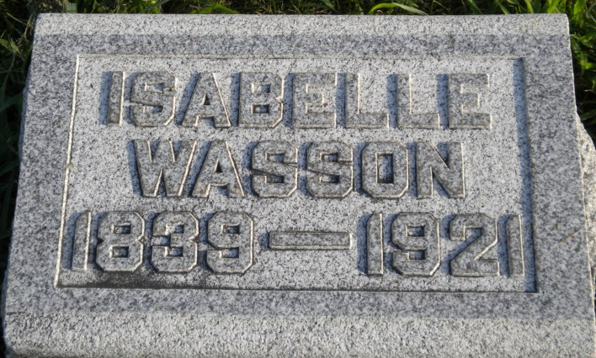
Photo by PLGS

ISABELLE WASSON, 81, DIED SUNDAY MORNING
Funeral Will be Held Tuesday Morning at 10 at Lancaster Chapel Church

Miss Isabelle Wasson, aged 81 years, died Sunday morning at the home of her niece, Mrs. J. D. Raver, northeast of the city. Death was due to infirmities of age.
Miss Wasson had been a resident of Wells County since 1841. She lived with her niece. She is the last of several children.
The deceased was born October 1, 1849 [sic], in Wayne County, Ohio, the daughter of George and Sarah Ashe Wasson. Preceding her in death were three brothers, John, James and Thomas, and a sister, Eliza Jane Nash.
The funeral service will be held at 10 o'clock Tuesday forenoon at Lancaster Chapel Church with burial at Elm Grove.

Unknown source

**
Indiana, U.S., Death Certificates, 1899-2017

Name Isabelle Wasson
Gender Female
Race White
Marital Status Single
Age 81
Birth Date 16 Oct 1839
Birth Place Ohio
Death Date 14 Aug 1921
Death Place Lancaster, Wells, Indiana, USA
Death Registration Date 1921
Father George Wasson
Mother Ash
Informant I. W. Wasson; Tocsin, Indiana
Burial August 16, 1921; Elm Grove Cemetery; Bluffton, Indiana

**
Isabelle Wasson from tree The Plummer, Wasson, Sowards, Jones, Sweeny, Hall, Trullender, Roop Line

Birth 1 Oct 1839 Wayne, Ohio, USA
Residence 1920 Wells, Indiana, USA
Death 1921 Wells Co. IN
Father George Wasson (1803-1855)
Mother Sarah Ash (1805-1895)

