Irwin W. Wasson
November 23, 1878 – July 15, 1963

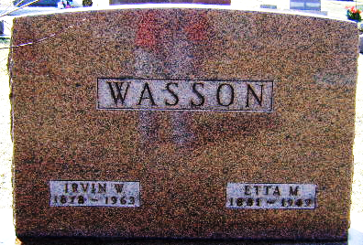
Photo by Bruce Sonner

Irvin W Wasson
in the Indiana, U.S., Death Certificates, 1899-2017
Name Irvin W Wasson
Gender Male
Race White
Marital Status Widowed
Age 84
Birth Date 23 Nov 1878
Birth Place Lancaster
Death Date 15 Jul 1963
Death Place Fort Wayne, Allen, Indiana, USA
Death Registration Date 1963
Father James Wasson
Mother Sarah Sweeney
Informant Wendell Wasson; son; Fort Wayne, Indiana
Burial July 17, 1963; Elm Grove Cemetery; Bluffton, Indiana

