Henry Herbert Wasson
May 19, 1879 – December 25, 1929

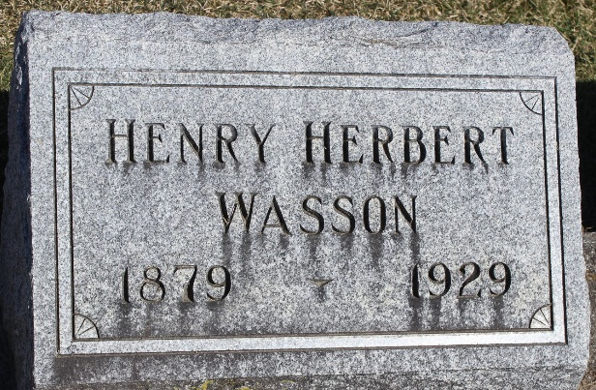
Photo by Tombstoner & Family

Henry H Wasson
in the Indiana, U.S., Death Certificates, 1899-2017
Name Henry H Wasson
Gender Male
Race White
Marital Status Married
Age 50 years, 7 months, 6 days
Birth Date 19 May (no year)
Birth Place Indiana
Death Date 25 Dec 1929
Death Place Franklin, Johnson, Indiana, USA
Death Registration Date 1929
Father John Wasson
Mother Elizabeth Greenfield
Spouse Mary F.
Informant Mrs. Henry Wasson; Franklin, Indiana
Burial December 29, 1929; Bluffton, Indiana

