Garnet E. (Hall) Wasson
March 2, 1893 – August 12, 1960

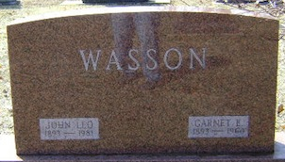
Photo by Bruce Sonner

MRS. LEO WASSON OF CRAIGVILLE DIES
Mrs. Garnet Wasson, 67, wife of Craigville Postmaster Leo Wasson, died at 11:45 a.m. Friday in the Wells County Hospital, where she had been a patient five weeks.
Born March 2, 1893, near Tocsin, she was the daughter of Theodore and Hattie Jones Hall. Her marriage to Mr. Wasson took place in 1914.
Mrs. Wasson was a member of the Evangelical United Brethren Church, the Pythian Sisters at Tocsin, the Emblem Club at Bluffton and the Home Economics Club.
Surviving, in addition to the husband, are two daughters, Mrs. Donald Hetrick and Mrs. Walter Kipfer, both of Fort Wayne; a brother, Roy Hall of Marathon, Fla., a sister, Mrs. Miles Stoneburner of Albion, and four grandsons.
Friends may call from 7 p.m. today until noon Monday at the Elzey Funeral Home at Ossian. The body will be taken at noon Monday to the Craigville Evangelical United Brethren Church to lie in state from 1 p.m. until time of services at 2 p.m. Rev. F. H. Pflugh will officiate and burial will be in the Elm Grove Cemetery.

Bluffton News Banner, Wells County, Indiana
Saturday, August 13, 1960

