George Raymond Wasson
July 6, 1875 – June 26, 1934

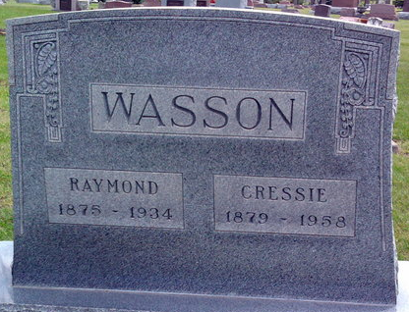
Photo by Tombstoner & Family

George Raymond Wasson
in the Indiana, U.S., Death Certificates, 1899-2017
Name George Raymond Wasson
Gender Male
Race White
Marital Status Married
Age 58
Birth Date 6 Jul 1875
Birth Place Wells County, Indiana
Death Date 26 Jun 1934
Death Place Jefferson, Wells, Indiana, USA
Death Registration Date 1934
Father James Wasson
Mother Sarah Sweeney
Spouse Cressie
Informant Mrs. Cressie Wasson; Craigville, Indiana
Burial June 29, 1934; Elm Grove Cemetery

