Frank L. Wasson
March 12, 1872 – December 25, 1938

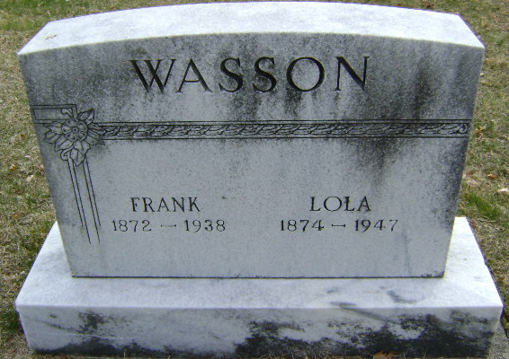
Photo by Bruce Sonner

Frank L Wassan
in the Indiana, U.S., Death Certificates, 1899-2017
Name Frank L Wasson
Gender Male
Race White
Marital Status Married
Age 66
Birth Date 12 Mar 1872
Birth Place Wels Co Indiana
Death Date 25 Dec 1938; suicide
Death Place Lancaster, Wells, Indiana, USA
Death Registration Date 1938
Father John Wasson
Mother Elizabeth Greenfield
Spouse Mary V Wible
Informant Mrs. Frank Wasson; Bluffton, Indiana
Burial December 27, 1938; Elm Grove Cemetery

