Etta May (Sowards) Wasson
March 11, 1881 – August 27, 1949

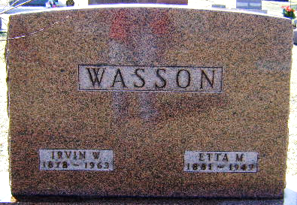
Photo by Bruce Sonner

Etta M Wasson
in the Indiana, U.S., Death Certificates, 1899-2017
Name Etta M Wasson
[Etta M Sowards]
Gender Female
Race White
Marital Status Married
Age 68
Birth Date 11 Mar 1881
Birth Place Wells County, Indiana
Death Date 27 Aug 1949
Death Place Tocsin, Wells, Indiana, USA
Death Registration Date 1949
Father William Sowards
Mother Martha Jane Hall
Informant Wendell J. Wasson; Tocsin, Indiana
Burial August 30, 1949; Elm Grove Cemetery; Bluffton, Indiana

