Edna M. (Plummer) Wasson
October 8, 1904 – March 23, 1978

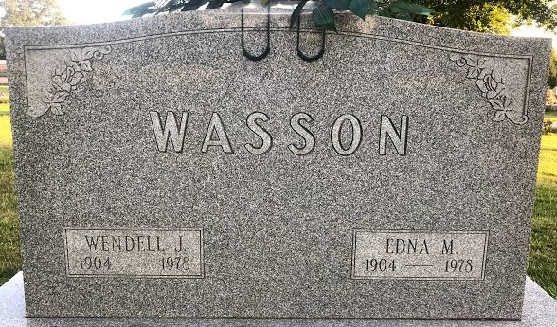
Photo by SMMR

Services for Edna M. Wasson, 73, a resident of Indian Village Health Center, will be at 2 p.m. Monday in Chalfant-Perry-Klaehn Funeral Home. She died Thursday evening at the Center.
Mrs. Wasson, a native of Tocsin, Ind., was co-owner of Miss and Master Children's Clothing Store for the past 20 years. Mrs. Wasson lived most of her life in Fort Wayne. Her husband, Wendell, with who she was in business, died March 2.
Surviving is her daughter, Mrs. Joann Ostrognai, Indianapolis; a son, Robert; a sister, Mrs. Dwight Jackson; and a brother, Earl Plummer, all of Fort Wayne.
Friends may call from 7 to 9 p.m. Sunday and 11 a.m. to 1 p.m. Monday at the funeral home. Burial will be in Elm Grove Cemetery, Bluffton.
Preferred memorials are to the Northeast Indiana Chapter, American Heart Association.

Journal Gazette, Allen County, Indiana
Sunday, March 26, 1978

**
Indiana, U.S., Death Certificates, 1899-2017
Name Edna M Wasson
[Edna M Plummer]
Gender Female
Race White
Marital Status Widowed
Age 73
Birth Date 8 Oct 1904
Birth Place Indiana
Death Date 23 Mar 1978
Death Place Fort Wayne, Allen, Indiana, USA
Death Registration Date 1978
Father William D Plummer
Mother Tida E Jones
Informant Mrs. James Ostrognai; Indianapolis, Indiana
Burial March 27, 1978; Elm Grove Cemetery; Bluffton, Indiana

