Cressie Pearl (Sowards) Wasson
January 19, 1879 – September 5, 1958

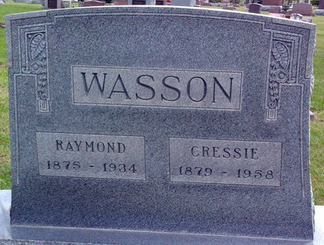
Photo by Tombstoner & Family

Cressie Pearl Wasson
in the Indiana, U.S., Death Certificates, 1899-2017
Name Cressie Pearl Wasson
[Cressie Pearl Sowards]
Gender Female
Race White
Marital Status Widowed
Age 79
Birth Date 19 Jan 1879
Birth Place Indiana
Death Date 5 Sep 1958
Death Place Craigville, Wells, Indiana, USA
Death Registration Date 1958
Father John M. Sowards
Mother Evelyn Wilkins
Informant Ralph Wasson; son; Craigville, Indiana
Burial September 7, 1958; Elm Grove Cemetery; Bluffton, Indiana

