Clem V. Wasson
December 16, 1884 – September 15, 1965

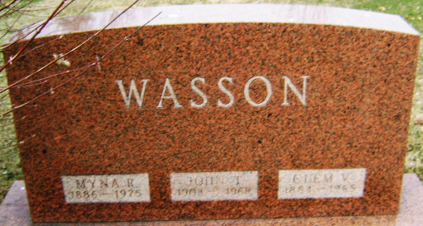
Photo by Bruce Sonner

Clem V Wasson
in the Indiana, U.S., Death Certificates, 1899-2017
Name Clem V Wasson
Gender Male
Race White
Marital Status Married
Age 80
Birth Date 16 Dec 1884
Birth Place Indiana
Death Date 15 Sep 1965
Death Place Adams, Adams, Indiana, USA
Death Registration Date 1965
Father Thomas Wasson
Mother Angie Vail
Informant Mrs. Clem Wasson; wife; Linn Grove, Indiana
Burial September 17, 1965; Elm Grove Cemetery; Bluffton, Indiana

