Estella May (Dettinger) Waschka
August 30, 1890 – June 18, 1981

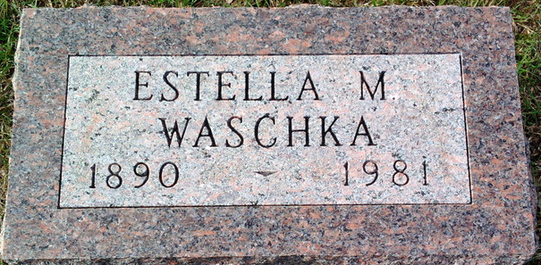
Photo by PLGS

ESTELLA WASCHKA DIES AT AGE 90; RITES SATURDAY
A former resident of Bluffton and Poneto, Mrs. Estella May Waschka, 90, died at 8:30 a.m. today at Cooper Community Care Center where she had resided the past three years.
A retired seamstress, Mrs. Waschka was born Aug. 30, 1890 in Adams County to Jacob and Rosetta Hower Dettinger. Her marriage to Fred Waschka took place in Bluffton in June 1912.
She is survived by two nieces, who reside in California.
Calling after 2 p.m. Friday will be at Goodwin Memorial Chapel with services there at 10 a.m. Saturday in charge of Rev. Neil D. Butcher. Burial will be in Elm Grove Cemetery.

News Banner, Wells County, Indiana
Thursday, June 18, 1981

