Chauncey W. Warthman
April 14, 1894 – May 26, 1971

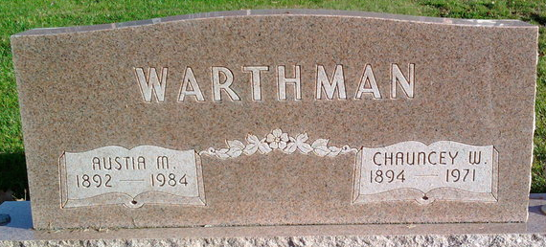
Photo by Thomas Liby

Chauncey Warthman is Taken by Death
Chauncey W. Warthman, 77 of 328 W. Miller St., Bluffton, father of Mrs. Forest (Vivian) Diehl of Preble, died at 9:10 p.m. Wednesday at the Clinic Hospital in Bluffton after suffering a fatal heart attack. Mr. Warthman was a member of the Wesleyan Church. He was a retired farmer.
He was born in Wells County on April 14, 1894, the son of Charles and Emma Abbott-Warthman, and was married to Austia Farmer on September 20, 1917.
Surviving are his wife; one daughter, Mrs. Forest (Vivian) Diehl of Preble; three sisters, Mrs. Ethel Gahman of Fort Wayne; Mrs. Alta Sills of Florida and Mrs. Nellie Mailer of Fort Wayne; one brother, Ford Warthman of Fort Wayne; five grandchildren and two great-grandchildren.
Funeral services will be conducted Friday at 3 p.m. at the Goodwin Funeral Home, with Rev. George Russell officiating. Burial will be in the Elm Grove Cemetery. Friends may call at the Goodwin Funeral Home after 7 p.m. today.
Decatur Daily Democrat, Adams County, Indiana
Thursday, May 27, 1971

