Austia M. (Farmer) Warthman
November 9, 1892 – April 8, 1984

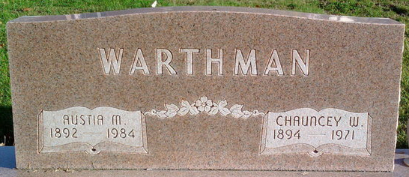
Photo by Thomas Liby

Austria M. Warthman
in the Indiana, U.S., Death Certificates, 1899-2017
Name Austia M. Warthman
[Austia M. Farmer]
Gender Female
Race White
Marital Status Widowed
Age 91
Birth Date 9 Nov 1892
Birth Place Indiana
Death Date 8 Apr 1984
Death Place Bluffton, Wells, Indiana, USA
Death Registration Date 1984
Father J. A. Farmer
Mother Sarah Baker
Informant Vivian Diehl; daughter; Preble, Indiana
Burial April 10, 1984; Elm Grove Cemetery; Bluffton, Indiana

