Harriett Eileen (Carnes) Warnock
May 30, 1918 – February 15, 2009

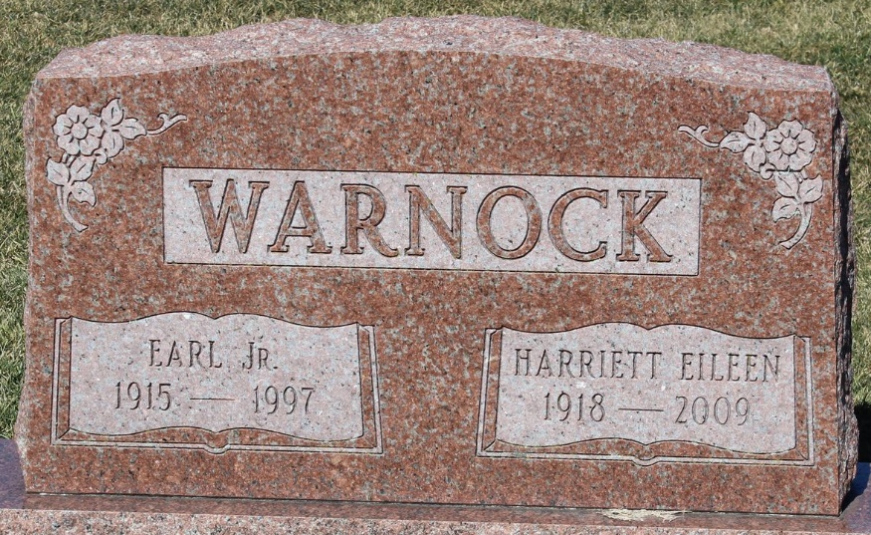
Photo by Tombstoner & Family

Harriett Eileen Warnock, 90, of Angola and formerly of Fort Wayne died Sunday, Feb. 15, 2009, at Cameron Woods Assisted Living in Angola. Mrs. Warnock was a homemaker and had lived in Bluffton, Portland and Fort Wayne prior to moving to Angola.
She was a graduate of Chester Center High School.
Mrs. Warnock was a member of Forest Park United Methodist Church in Fort Wayne and was a lifetime member of the Order of the Eastern Star in Portland, Ind.
She had been a Girl Scout leader and a life member of Gamma Nu Sorority. She enjoyed her family, reading, gardening and working jigsaw puzzles and crossword puzzles.
She was born May 30, 1918, in Keystone, Ind., to Azel Ralph and Lola Ethel (Feltt) Carnes. She married Earl Warnock Jr. on Oct. 7, 1937, in Keystone. He preceded her in death on May 15, 1997.
Surviving are three daughters and two sons-in-law, Priscilla and John DeMarco of Lake George at Fremont, Rebecca and James Noverske of Sparks, Nev., and Melissa Bouland of Mt. Vernon, Ill.; eight grandchildren; nine great-grandchildren; a sister, Veora Fabrowicz of Las Cruces, N.M.; and a brother and sister-in-law, William and Neola Carnes of Indianapolis.
She was also preceded in death by her parents; three brothers, Wayne Carnes, Alfred Carnes and Edward Carnes; three sisters, Henrietta Bender, Roberta Leker and Doris Carnes; and one granddaughter.
Funeral services will be at 11 a.m. Friday, Feb. 20, 2009, at Beams Funeral Home in Fremont with the Rev. Keith Olson officiating. Burial will be in Elm Grove Cemetery at Bluffton. Calling will be from 6-8 p.m. Thursday, Feb. 19, 2009, at Beams Funeral Home.
Memorials are to the Steuben County Community Foundation Diabetes Fund.

Bluffton News-Banner, Wells County, Indiana
February 16, 2009

