Earl Warnock, Jr.
March 1, 1915 – May 15, 1997

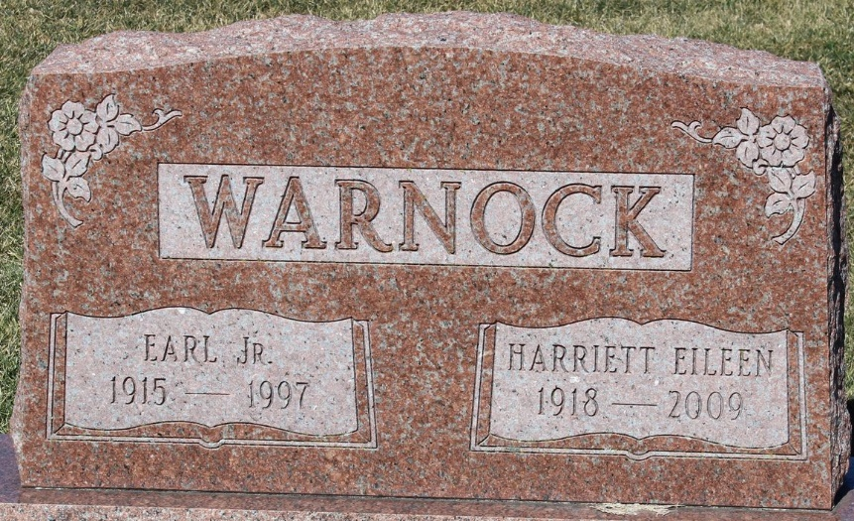
Photo by Tombstoner & Family

Earl Warnock
in the Indiana, U.S., Death Certificates, 1899-2017
Name Earl Warnock
Gender Male
Race White
Marital Status Married
Age 82
Birth Date 1 Mar 1915
Birth Place Bluffton, Indiana
Death Date 15 May 1997
Death Place Fort Wayne, Allen, Indiana, USA
Death Registration Date 1997
Father Earl M. Warnock
Mother Hazel McAfee
Spouse Harriett Eileen Carnes
Informant Mrs. Harriett Eileen Warnock; wife; Fort Wayne, Indiana
Burial May 19, 1997; Elm Grove Cemetery; Bluffton, Indiana

