Theodore O. Warner
November 24, 1842 – January 6, 1919

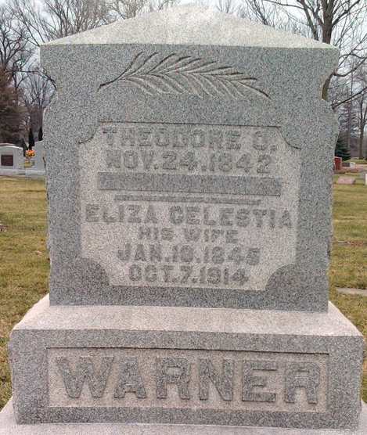
Photo by Thomas Liby

Theodore Warner
in the Indiana, U.S., Death Certificates, 1899-2017
Name Thedore Warner
Gender Male
Race White
Marital Status Widowed
Age 76
Birth Date 30 Nov 1842
Birth Place Dayton, Ohio
Death Date 6 Jan 1919
Death Place Poneto, Wells, Indiana, USA
Death Registration Date 1919
Father Thomas Warner
Mother Rebeca Winters
Spouse Celestia
Informant Frank Warner; Poneto, Indiana
Burial January 8, 1919; Elm Grove Cemetery

