Rosetta (Risser) Warner
February 26, 1882 – January 24, 1966

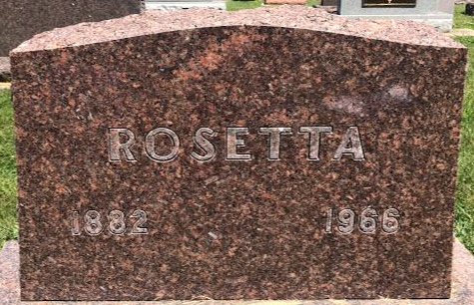
Photo by SMMR

Rosetta Warner
in the Florida, U.S., Death Index, 1877-1998
Name Rosetta Warner
Gender Female
Race White
Death Date Jan 1966
Death Place Broward, Florida, United States

**
U.S., Social Security Applications and Claims Index, 1936-2007
Name Rosetta Warner
[Rosetta Risser]
Gender Female
Race White
Birth Date 26 Feb 1882
Birth Place Wells County, Indiana
Father William H Risser
Mother Mary A Rose
SSN xxx
Notes Oct 1965: Name listed as ROSETTA WARNER

**
Rosetta Risser from tree Stoner/Risser/Clark/Jackson
Birth 26 Feb 1882 Wells, Indiana, USA
Marriage 15 Dec 1902 Wells, Indiana, USA
Residence 1950 Mason, Ingham, Michigan, USA
Death 24 Jan 1966 Pompano Beach, Broward, Florida, USA
Father William Henry Risser (1853-1933)
Mother Mary Alice Rose (1854-1940)
Spouse Albert Warner (1880-1964)

