James H. Warner
August 5, 1847 – January 9, 1931

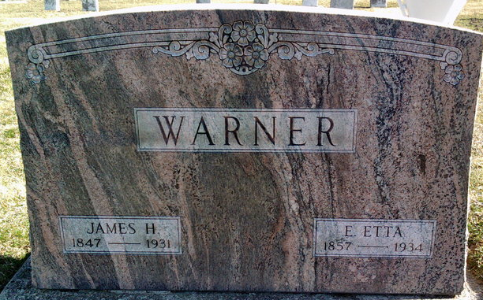
Photo by Thomas Liby

James H Warner
in the Indiana, U.S., Death Certificates, 1899-2017
Name James H Warner
Gender Male
Race White
Marital Status Married
Age 83
Birth Date 5 Aug 1847
Birth Place W. Va.
Death Date 9 Jan 1931
Death Place Hartford City, Blackford, Indiana, USA
Death Registration Date 1931
Father Zebider Warner
Mother Felby Bland
Spouse Etta
Informant Mrs. Etta Warner; Hartford City, Indiana
Burial January 11, 1931; Bluffton, Indiana

