Eliza Etta (Thompson) Warner
October 9, 1856 – April 12, 1934

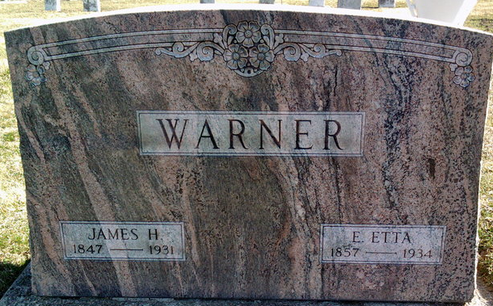
Photo by Thomas Liby

Eliza Etta Warner
in the Indiana, U.S., Death Certificates, 1899-2017
Name Eliza Etta Warner
[Eliza Etta Thompson]
Gender Female
Race White
Marital Status Widow
Age 77
Birth Date 9 Oct 1856
Birth Place Ohio
Death Date 12 Apr 1934
Death Place Hartford City, Blackford, Indiana, USA
Death Registration Date 1934
Father Joseph S Thompson
Mother Francis M Brickfield
Spouse James H. Warner
Informant Frank Alberson; Hartford City, Indiana
Burial April 15, 1934; Bluffton, Indiana

