Eliza Celestia (Yeazel) Warner
January 10, 1845 – October 7, 1914

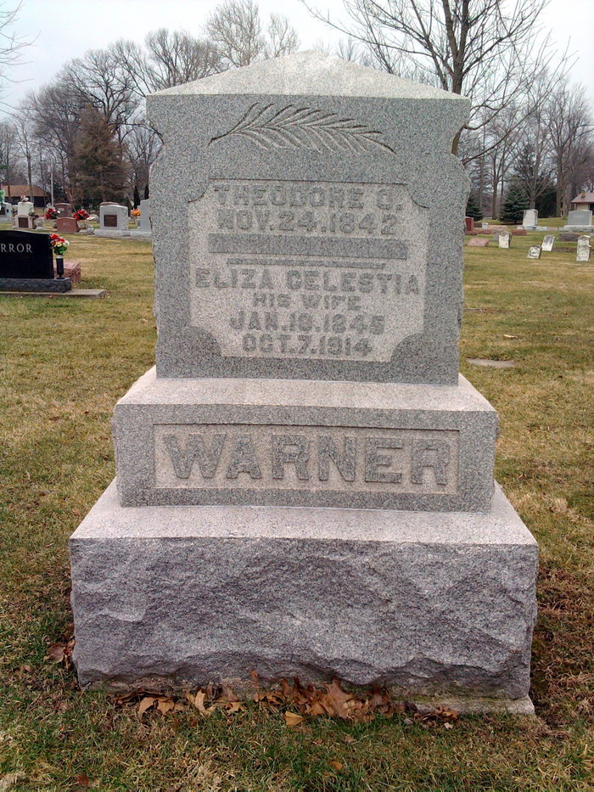
Photo by Thomas Liby

