Harry D. Ward
April 16, 1882 – April 15, 1954

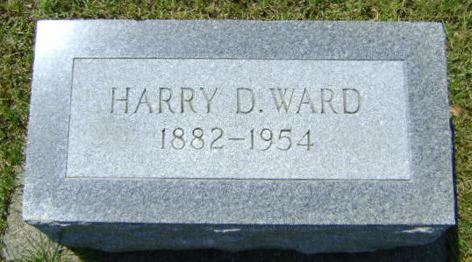
Photo by Bruce Sonner

Harry D Ward
in the Indiana, U.S., Death Certificates, 1899-2017
Name Harry D Ward
Gender Male
Race White
Marital Status Widowed
Age 72
Birth Date 16 Apr 1881(sic)
Birth Place Ohio
Death Date 15 Apr 1954
Death Place Fort Wayne, Allen, Indiana, USA
Death Registration Date 1954
Father Francis Ward
Mother Mary Eahart
Informant Vera Faherty; Fort Wayne, Indiana
Burial April 17, 1954; Elmgrove Cemetery; Bluffton, Indiana

