Bessie Eleanor (Hardwidge) Ward
October 25, 1891 – April 2, 1954

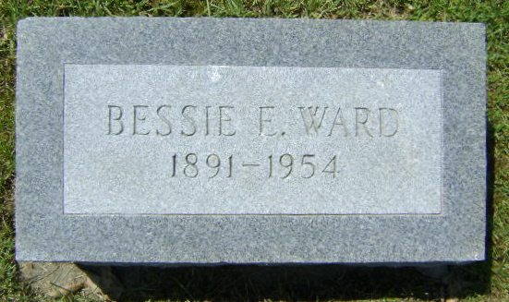
Photo by Bruce Sonner

Elennor Bessie Ward
in the Indiana, U.S., Death Certificates, 1899-2017
Name Eleanor Bessie Ward
[Eleanor Bessie Hardwidge]
Gender Female
Race White
Marital Status Married
Age 63
Birth Date 25 Oct 1890 [sic]
Birth Place Indiana
Death Date 2 Apr 1954
Death Place Poneto, Wells, Indiana, USA
Death Registration Date 1954
Father John Hardwidge
Mother Ella Galivan
Informant Harry Ward; Poneto, Indiana
Burial April 5, 1954; Elm Grove Cemetery; Bluffton, Indiana

