Franklyn Earl Waltz
December 4, 1888 – March 4, 1923

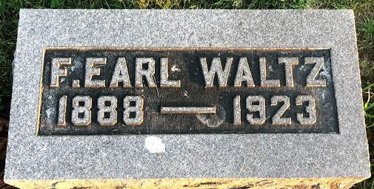
Photo by SMMR

Franklyn Earl Waltz from tree Peel
Birth 4 Dec 1888 Blackford, Indiana, USA
Residence Jan 1920 Lump Gulch, Jefferson, Montana, USA
Death 4 Mar 1923 Helena, Lewis and Clark, Montana, USA
Father Franklin Pierce Waltz (1861-1911)
Mother Elizabeth E. DeWitt (1865-1956)

