Frances M. (Davis) Walsh
December 19, 1927 – April 19, 1999

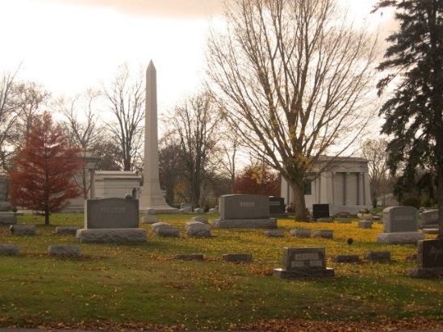
Photo by Tombstoner & Family

Frances M. Walsh, 71
Frances M. Walsh, 71, died at 2:14 a.m. today at her residence at 5629S Meridian Rd. in Poneto. Death was attributed to cancer.
Mrs. Walsh was employed 20 years at Hall's Catering in Fort Wayne.
She was a native of Fort Wayne but had resided in Wells County most of her life.
She was born Dec. 19, 1927 to Arch and Dale Buckner Davis. A first marriage was to Robert Tarr, who died in 1954.
She was a former member of the Indiana Trotters and Pacers Association.
Mrs. Walsh is survived by a son, David Walsh of Poneto; a daughter, Mrs. Jerry (Camela) Mount of Fort Wayne; a brother, Donald E. Davis of rural Poneto; and three grandchildren.
A graveside service will be conducted at 10:30 a.m. Wednesday at Elm Grove Cemetery with Rev. Kenneth Sarrazine of the St. Joseph Catholic Church in Roanoke officiating. Thoma/Rich, Hewitt & Chaney Funeral Home is in charge of arrangements and viewing will be private.
Memorials to the American Cancer Society.

Thoma/Rich Funeral Home, Wells County, Indiana
April 20, 1999
**
Frances M. Walsh
in the Indiana, U.S., Death Certificates, 1899-2017

Name Frances M. Walsh
[Frances M. Davis]
Gender Female
Race White
Marital Status Divorced
Age 71
Birth Date 19 Dec 1927
Birth Place Fort Wayne, Indiana
Death Date 19 Apr 1999
Death Place Poneto, Wells, Indiana, USA
Death Registration Date 1999
Father Arch Davis
Mother Dale Buckner
Informant Camela Mount; daughter; Fort Wayne, Indiana
Burial April 21, 1999; Elm Grove Cemetery; Bluffton, Indiana

