Ralph E. Walser
August 22, 1891 – September 21, 1910

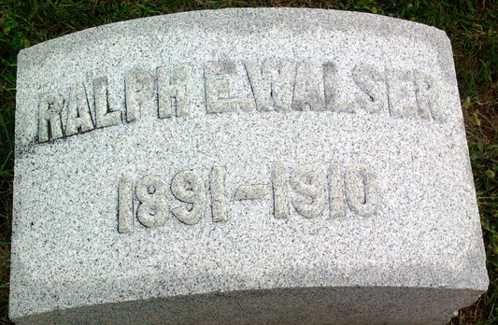
Photo by Thomas Liby

Ralph Walser
in the Indiana, U.S., Death Certificates, 1899-2017
Name Ralph Walser
Gender Male
Race White
Marital Status Single
Age 19
Birth Date 22 Aug 1891
Birth Place Indiana
Death Date 21 Sep 1910
Death Place Jefferson, Wells, Indiana, USA
Death Registration Date 1910
Father Dee Walser
Mother Elizabeth Bauman
Informant Family; city
Burial September 23, 1910; Elm Grove Cemetery

