Eric D. Walser
October 26, 1865 – December 21, 1940

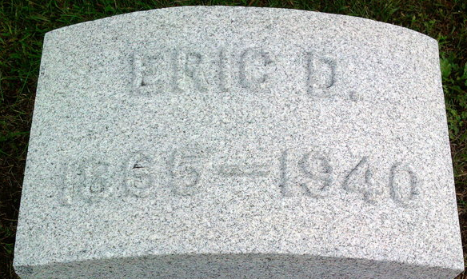
Photo by Thomas Liby

Eric D Walser
in the Ohio, U.S., Death Records, 1908-1932, 1938-2022
Name Eric D Walser
Death Date 21 Dec 1940
Death Place Sandusky, Ohio, USA
**
Eric D Walser from tree Haley Family Tree
Birth 26 Oct 1865 Wells, Indiana, USA
Marriage 1890 Wells, Indiana, USA
Residence 1930 Bellevue, Huron, Ohio, USA
Death 21 Dec 1940 Clyde, Sandusky, Ohio, USA
Father Rannals A Walser (1825-1912)
Mother Cynthia Ann Anderson (1826-1887)
Spouse Elizabeth H Bauman (1868-1931)

