Elizabeth H. (Bauman) Walser
May 23, 1868 – September 12, 1931

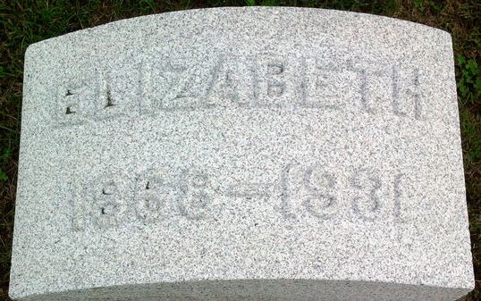
Photo by Thomas Liby

Elizabeth H Bauman from tree Haley Family Tree
Birth 23 May 1868 Ohio, USA
Marriage 1890 Wells, Indiana, USA
Residence 1930 Bellevue, Huron, Ohio, USA
Death 12 Sep 1931 Bellevue, Huron, Ohio, USA
Father Phillip Phil Bauman (Born 1837)
Mother Annie ? - Bauman (1843-1920)
Spouse Eric D Walser (1865-1940)

