Mary Ellen Walmer
April 13, 1860 – May 25, 1950

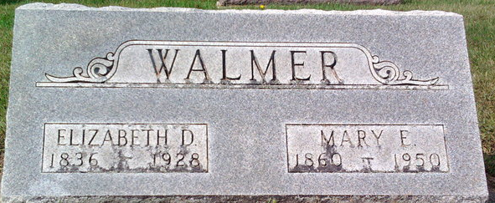
Photo by Thomas Liby

Mary Ellen Walmer
in the Indiana, U.S., Death Certificates, 1899-2017
Name Mary Ellen Walmer
Gender Female
Race White
Marital Status Never Married (Single)
Age 90
Birth Date 13 Apr 1860
Birth Place Indiana
Death Date 25 May 1950
Death Place Bluffton, Wells, Indiana, USA
Death Registration Date 1950
Father Jacob Walmer
Mother Elizabeth Decker
Informant Mary Webber
Burial May 27, 1950; Elm Grove Cemetery; Bluffton, Indiana

