John D. Walmer
May 16, 1865 – October 21, 1934

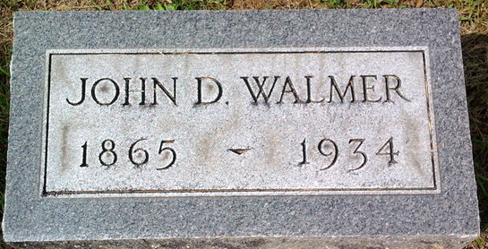
Photo by Thomas Liby

John D. Walmer
in the Indiana, U.S., Death Certificates, 1899-2017
Name John D. Walmer
Gender Male
Race White
Marital Status Single
Age 69
Birth Date 16 May 1865
Birth Place Murray, Indiana
Death Date 21 Oct 1934
Death Place Bluffton, Wells, Indiana, USA
Death Registration Date 1934
Father Jacob Walmer
Mother Elizabeth Decker
Informant Family
Burial October 23, 1934; Elm Grove Cemetery

