George H. Walmer
May 23, 1868 – July 11, 1935

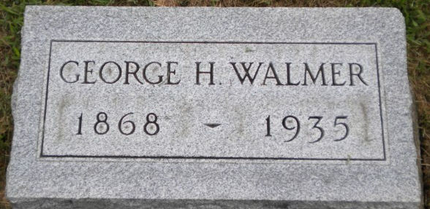
Photo by PLGS

George H Walmer
in the Indiana, U.S., Death Certificates, 1899-2017
Name George H Walmer
Gender Male
Race White
Marital Status Divorced
Age 67
Birth Date 23 May 1868
Birth Place Lancaster Twp-Indiana
Death Date 11 Jul 1935
Death Place Bluffton, Wells, Indiana, USA
Death Registration Date 1935
Father Jacob Walmer
Mother Elizabeth Decker
Spouse Alice Little
Informant Family
Burial July 13, 1935; Elm Grove Cemetery

