Elizabeth (Decker) Walmer
January 24, 1836 – September 16, 1928

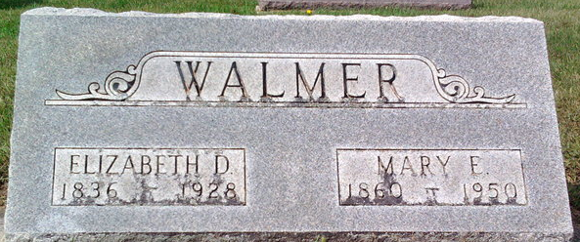
Photo by Thomas Liby

Elizabeth Walmer
in the Indiana, U.S., Death Certificates, 1899-2017
Name Elizabeth Walmer
[Elizabeth Decker]
Gender Female
Race White
Marital Status Widow
Age 92
Birth Date 24 Jan 1836
Birth Place Berks Co Pennsylvania
Death Date 16 Sep 1928
Death Place Bluffton, Wells, Indiana, USA
Death Registration Date 1928
Father George Decker
Mother Elizabeth Lesh
Spouse Jacob Walmer
Informant John Walmer; Bluffton, Indiana
Burial September 20, 1928; Elm Grove Cemetery

