John A. Walker
March 1, 1847 – January 18, 1926

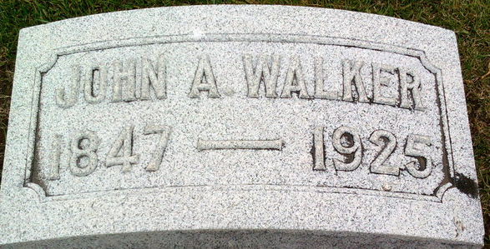
Photo by Thomas Liby

John A Walker
in the Indiana, U.S., Death Certificates, 1899-2017
Name John A Walker
Gender Male
Race White
Marital Status Married
Age 78
Birth Date 1 Mar 1847
Birth Place Union, Indiana
Death Date 18 Jan 1926
Death Place Wayne, Allen, Indiana, USA
Death Registration Date 1926-1927
Father Leonard Walker
Mother Mallinda Davis
Spouse Alforetta Austin
Informant Mrs. J. A. Walker; Bluffton, Indiana
Burial January 22, 1926; Elm Grove Cemetery

