Earl J. Walker
February 20, 1880 – February 5, 1946

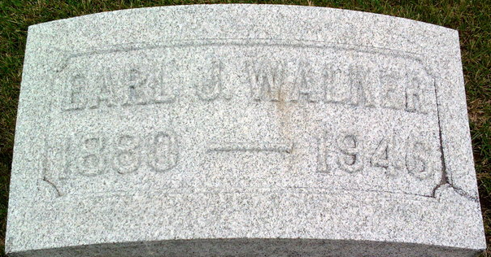
Photo by Thomas Liby

Earl J. Walker
in the Illinois, U.S., Deaths and Stillbirths Index, 1916-1947
Name Earl J. Walker
Birth Date 20 Feb 1880
Birth Place Bluffton, Indiana
Death Date 5 Feb 1946
Death Place Chicago, Cook, Illinois
Burial Date 8 Feb 1946
Burial Place Skokie, Cook, Illinois
Cemetery Name Memorial Park
Death Age 65
Occupation Lawyer
Race White
Marital Status M
Gender Male
Residence Evanston, Cook, Illinois
Father Name John Walker
Mother Name Austin
Spouse Name Margaret H.
FHL Film Number 1985094

