Alforetta A. (Austin) Walker
March 5, 1849 – February 24, 1934

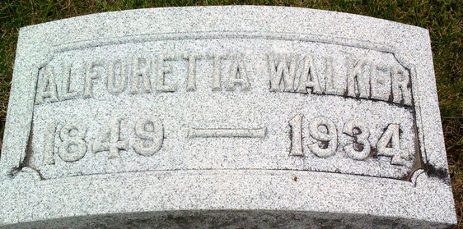
Photo by Thomas Liby

Alforetta A Walker
in the Indiana, U.S., Death Certificates, 1899-2017
Name Alforetta A Walker
[Alforetta A Austin]
Gender Female
Race White
Marital Status Widowed
Age 84
Birth Date 5 Mar 1849
Birth Place Ohio
Death Date 26 [sic] Feb 1934
Death Place Bluffton, Wells, Indiana, USA
Death Registration Date 1934
Father Chas B Austin
Mother Sarah Bernean
Spouse John A Walker
Informant Earl J. Walker; Evanston, Illinois
Burial February 26, 1934; Elm Grove Cemetery

