Catherine E. Walborn
August 3, 1878 – November 1, 1950

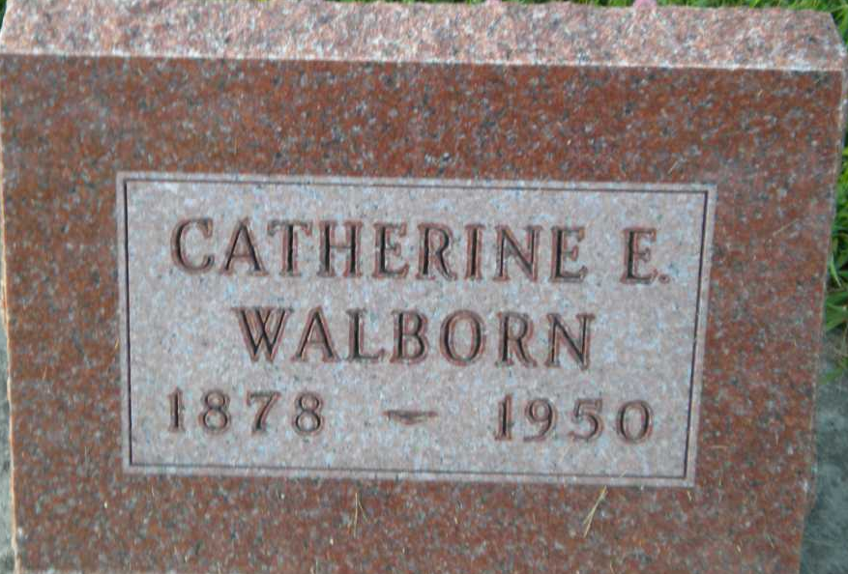
Photo by PLGS

Cathrine Walborn
in the Indiana, U.S., Death Certificates, 1899-2017
Name Cathrine Walborn
Gender Female
Race White
Age 72
Marital Status Never Married (Single)
Birth Date 3 Aug 1878
Birth Place Pennsylvania
Death Date 1 Nov 1950
Death Place Bluffton, Wells, Indiana, USA
Death Registration Date 1950
Father: Franklin Walborn
Mother: Amanda Staiger
Informant: Mrs. George Masterson
Burial: November 3, 1950; Elm Grove Cemetery; Bluffton, Indiana

