Lynda Jean (Walters) Waitman
October 19, 1939 – August 28, 1997

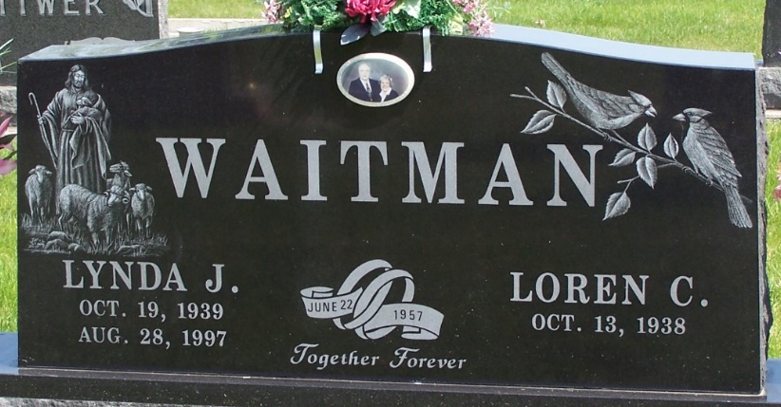
Photo by Thomas Liby

Lynda Jean Waitman
in the Indiana, U.S., Death Certificates, 1899-2017
Name Lynda Jean Waitman
[Lynda Jean Walters]
Gender Female
Race White
Marital Status Married
Age 57
Birth Date 19 Oct 1939
Birth Place Gary, Indiana
Death Date 28 Aug 1997
Death Place Roanoke, Allen, Indiana, USA
Death Registration Date 1997
Father Charles Bishop Walters
Mother Jean Beleslin
Spouse Loren C. Waitman
Informant Loren Waitman; husband; Roanoke, Indiana
Burial August 31, 1997; Elm Grove Cemetery; Bluffton, Indiana

