Loren C. Waitman
October 13, 1938 – March 11, 2011

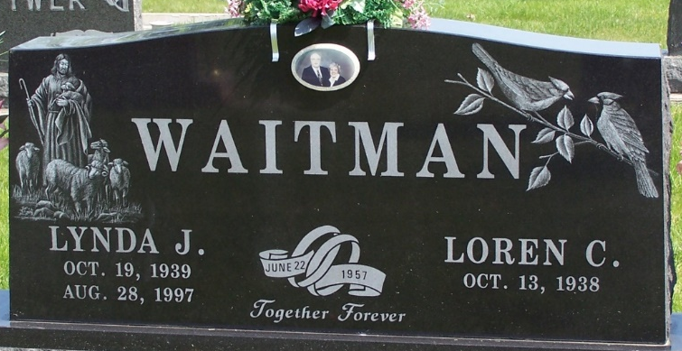
Photo by Thomas Liby

Loren C. Waitman, 72, died March 11, 2011 at Lutheran Hospital. He was born Oct. 13, 1938, in Lima to Glenn and Lucille Gossard Waitman, who preceded him in death. He married Lynda Jean Walters, who died in 1997. He then married Barbara A. Underwood, who survives in Roanoke.
Mr. Waitman retired in 2003 as an elevator adjuster and installer. He had worked for many companies, including Bramalea, Haughton, Schindler and Millar elevator companies. Mr. Waitman was a member of Blackhawk Ministries and a 1956 graduate of Waynesfield-Goshen High School.
Survivors also include a daughter, Jeanne M. Franke, of Roanoke, Ind.; grandchildren Aaron and Lauren Franke; a brother, Paul Waitman, of Waynesfield; stepchildren Melany (Bill) Stokes, of Lakeview, Denella Engle, of Lafayette, James (Tammy) Engle, of Elida, Steven Engle, of Lafayette, and Sondra (Tim) Amstutz, of Bluffton, Ohio; nine step grandchildren, seven step great-grandchildren and several nieces and nephews. He was preceded in death by a sister, Carol Kinstle; two brothers, Richard "Bud" Waitman and Leroy Waitman; and a stepson, Gregory Engle.
Services will begin at 11 a.m. Friday at Elzey-Patterson-Rodak Funeral Home, 120 W. Mill St., Ossian, Ind.

Elzey Funeral Home, Wells County, Indiana
March 12, 2011

