Lucille A. (Knoke) Wahman
November 22, 1897 – September 12, 1987

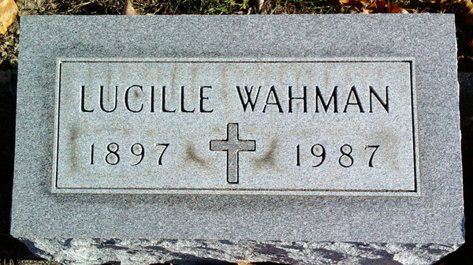
Photo by Thomas Liby

Lucille A Wahman
in the Indiana, U.S., Death Certificates, 1899-2017
Name Lucille A Wahman
[Lucille A Knoke]
Gender Female
Race White
Marital Status Widowed
Age 89
Birth Date 22 Nov 1897
Birth Place Indiana
Death Date 12 Sep 1987
Death Place Bluffton, Wells, Indiana, USA
Death Registration Date 1987
Father Henry Knoke
Mother Katherine Scheer
Spouse Lee Wahman
Informant Donnajeanne Wahman; daughter; Bluffton, Indiana
Burial September 16, 1987; Elm Grove Cemetery; Bluffton, Indiana

